UPHC, Seikhazou
Laboratory

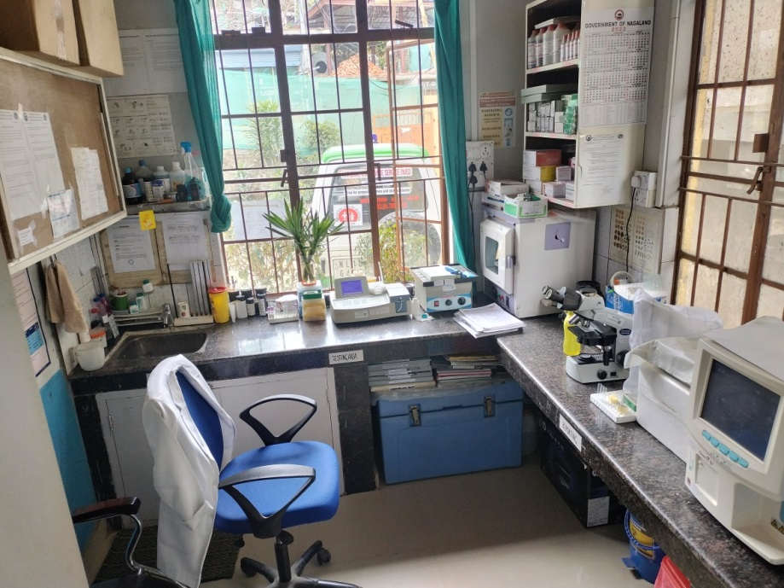
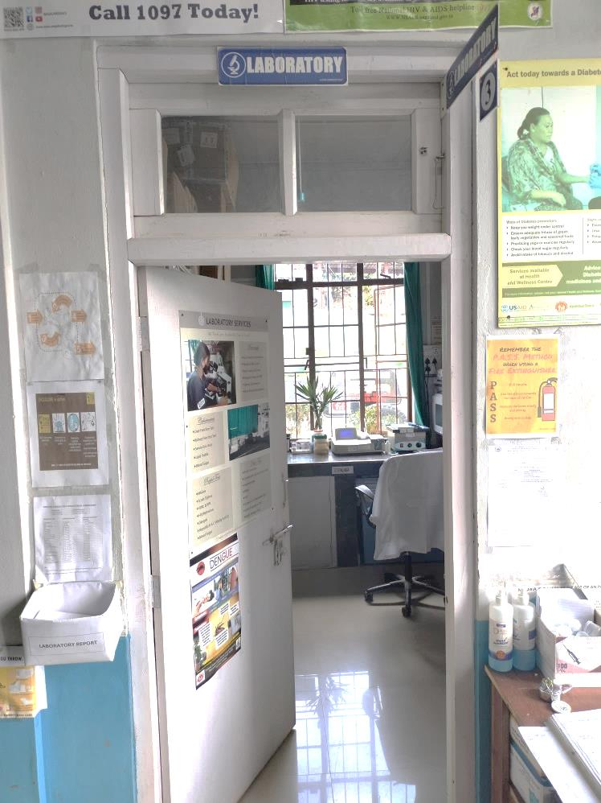

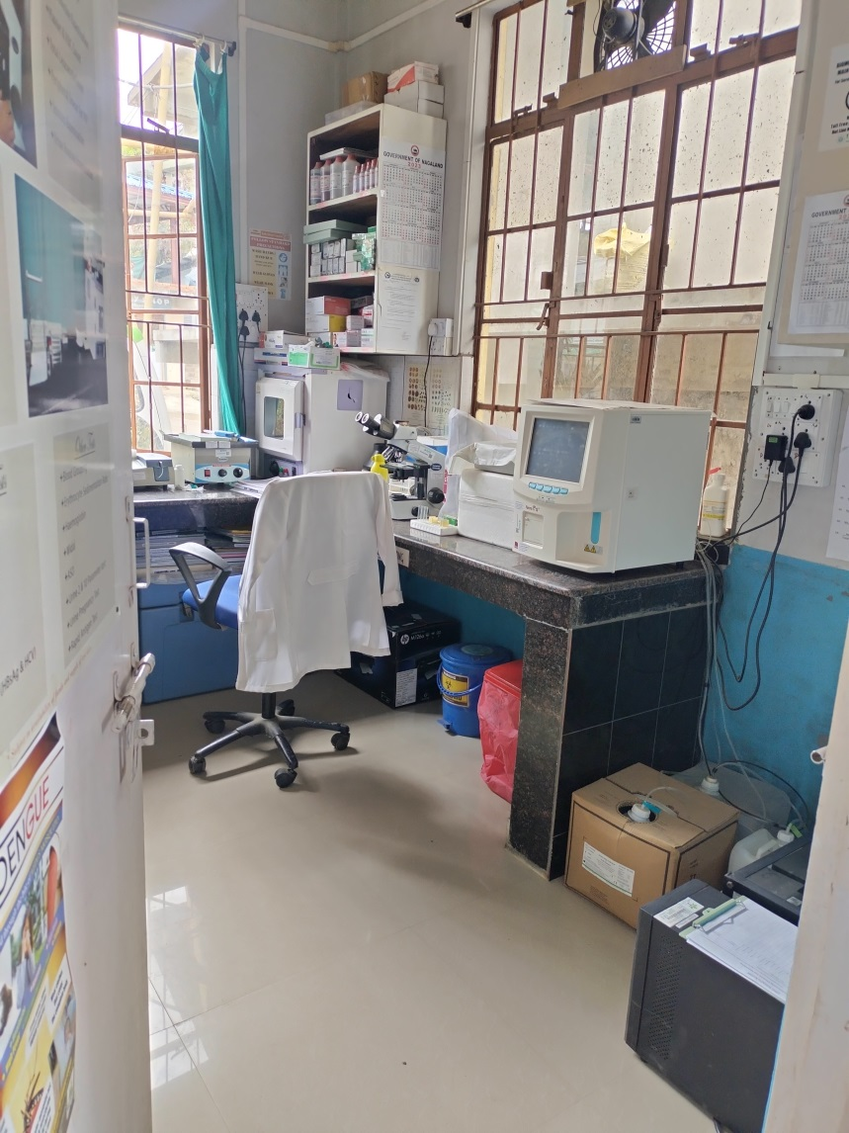

URBAN PRIMARY HEALTH CENTRE, SEIKHAZOU
SL. NO | NAME OF TEST
1 | RAPID TEST FOR HIV
2 | RDT KIT
3 | PBS MALARIA
4 | WIDAL
5 | HAEMOGLOBIN (Hb)
6 | SCRUB TYPHUS
7 | BLOOD GROUPING (BG)
8 | RH Factor
9 | PREGNANCY TEST (PT)
10 | HBs AG
11 | VDRL
12 | ESR
13 | URINE RE
14 | DIFFERENTIAL LEUCOCYTE COUNT (DLC)
15 | TOTAL LEUCOCYTE COUNT (TLC)
16 | Platelet Count
17 | RBC Count
18 | URINE ALBUMIN
19 | URINE SUGAR
20 | DENGUE
21 | HCV Ab
22 | FASTING BLOOD SUGAR
23 | PP2BS
24 | RANDOMN BLOOD SUGAR
25 | SERUM CREATININE
26 | BLOOD UREA NITROGEN
27 | SGPT
28 | SGOT
29 | ALP
30 | TOTAL BILIRUBIN
31 | DIRECT BILIRUBIN
32 | CHOLESTEROL
33 | TRIGLYCERIDE
34 | URIC ACID
35 | SERUM ALBUMIN
36 | SPUTUM A
37 | SPUTUM B
38 | Bleeding time
39 | Clotting time
40 | RAT

